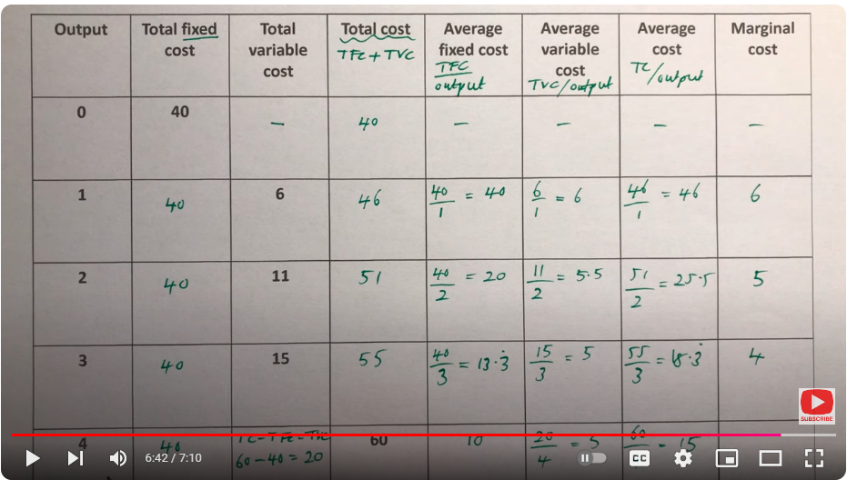

Margional cost is the additional cost

Formula of Margional Cost= Change in TC / Change in Output